STM USB HARDWARE DESIGN AND COMPONENTS

TERMINOLOGIES :
Abbreviation | Full Name
PHY | Physical Layer
ULPI | UTMI+ Low Pin Interface
UTMI | USB 2.0 Transceiver Macrocell Interface
HSI | High-Speed Internal
HSE | High-Speed External
DMA | Direct Memory Access
ESD | Electrostatic Discharge
SPI | Serial Peripheral Interface
UART | Universal Asynchronous Receiver-Transmitter

PHY (Physical Layer Transceiver)
Role: The PHY is responsible for the physical layer of communication . It handles the electrical signaling, data encoding/decoding, and other low-level functions required for communication.
Functions:
- Signal Transmission and Reception: Converts digital data from the microcontroller into electrical signals for transmission over USB cables and vice versa.
- Clock Recovery: Ensures data is synchronized correctly by recovering the clock from the incoming data stream.
USB Protocol Hardware Attachment
Internal PHY Setup
When using an internal PHY, the microcontroller directly interfaces with the USB port through a set of dedicated pins. The internal PHY handles the physical layer tasks, making the design simpler and reducing the need for external components.
Diagram

Internal PHY: Integrated within the microcontroller, directly connects to the USB port, simplifying design and reducing component count. Commonly used for Full-Speed (FS) USB and some High-Speed (HS) USB applications.
External PHY Setup
In an external PHY setup, the microcontroller communicates with the external PHY chip through the ULPI interface. The external PHY then connects to the USB port, handling the physical layer tasks and enabling High-Speed USB communication.
Diagram
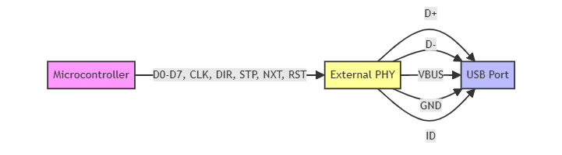
ULPI interface
- External PHY: A separate chip that interfaces with the microcontroller via the ULPI interface. Provides High-Speed USB capabilities and enhanced performance. Necessary for microcontrollers that do not have an integrated HS PHY.

- ULPI Interface: Consists of 12 pins (Data Lines D0-D7, Clock CLK, Direction DIR, Strobe STP, Next NXT, and optional Reset RST) used for communication between the microcontroller and the external PHY

- Feature | Internal PHY | External PHY
Location | Integrated within the microcontroller chip | Separate component mounted on the board
Usage | Simplifies design, reduces component count | Required for High-Speed USB if internal HS PHY is not available
Common Applications | Full-Speed USB, sometimes High-Speed USB(12MB/s) | High-Speed USB (480 Mbps)
Clocking | Requires external HSE crystal (except crystal-less devices) | Depends on the specific PHY IC, often requires precise clocking
Connection | Internal to the microcontroller | Connected to the microcontroller via ULPI interface
Examples (STM32)(please verify) | STM32F0, STM32F1, STM32F3, STM32F4, STM32L0, STM32L4, STM32H7 series | STM32F205, STM32F207, STM32F215, STM32F217, STM32F405, STM32F407, STM32F415, STM32F417, STM32F429, STM32F439, STM32F745, STM32F746, STM32F756, STM32F765, STM32F767, STM32F769

BOARDS with internal FS PHY | Almost everyone
Boards with internal HS PHY | F7 H7x3
Boards with External HS PHY | F2 .
Boards that support HS without external PHY are considered crystal-less devices
HSI (High-Speed Internal) and HSE (High-Speed External) Clocks
Role: The HSI and HSE clocks provide the main clock sources for the microcontroller, ensuring that it operates at the correct frequency. They are crucial for the overall timing and synchronization of the microcontroller's operations.
HSI (High-Speed Internal):
- Internal Oscillator: Built into the microcontroller.
- Typical Uses: Initial startup clock, system clock for applications where high precision is not critical, and low-cost designs.
HSE (High-Speed External):
- External Oscillator: Requires an external crystal or oscillator.
- Typical Uses: System clock for applications requiring high precision and stability, USB communication, and input to the PLL for generating higher frequencies

Clock Source | Description | Usage | Examples of STM32 Devices
HSI oscillator clock (High-Speed Internal) | Internal oscillator built into the microcontroller. Typically fixed at 8 MHz or 16 MHz. No need for external components. | General-purpose clock generation, suitable for low-power applications and initial startup. | STM32F0  STM32F1  STM32F3  STM32L0  STM32L4
HSE crystal clock (High-Speed External) | External crystal or oscillator connected to the microcontroller. Provides higher accuracy and stability. Typically required for precise timing and USB operations. | Precise clock generation, required for USB operations, suitable for applications needing high accuracy and stability. | STM32F2  STM32F4  STM32F7  STM32H7  STM32L4

USB Port Pins
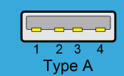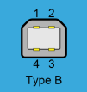
A USB port typically has 4 or 5 pins, depending on the specific application and requirements:
Type A and Type B ports have 4 Pins :
- D+ (Data Positive): One of the differential data lines used for USB communication.
- D- (Data Negative): The other differential data line used for USB communication.
- VBUS: Provides power from the USB host or hub (typically 5V).
- GND: Ground connection.
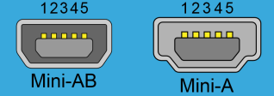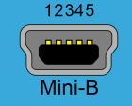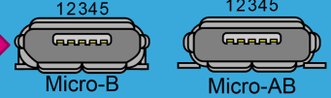
Mini and micro ports nhave a fifth Pin named :
- ID (Identification): (Optional) Used in USB On-The-Go (OTG) to determine the role of the device (host or peripheral).
USB -TYPE-C Pins configuration
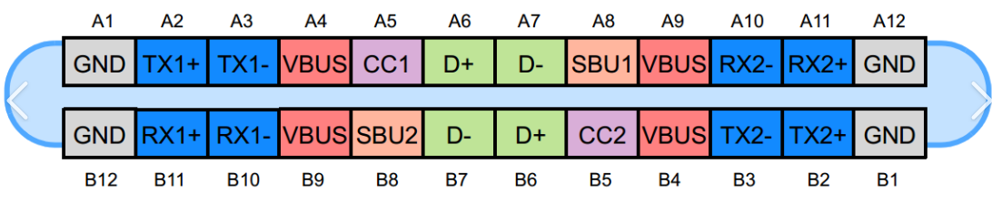
Power and Ground Pins
- VBUS (4 pins): These pins provide power to the connected device. The voltage can range from 5V to 20V, depending on the power delivery specifications.
- GND (4 pins): These pins are the ground connections for the power and signal return paths.
USB 2.0 Pins
- D+ and D- (2 pins): These pins are used for USB 2.0 data transfer. They are located in the middle of the connector and are always connected, regardless of the plug orientation.
SuperSpeed Pins (USB 3.x)
- TX1+/TX1- and RX1+/RX1- (4 pins): These pins are used for SuperSpeed data transfer (USB 3.x) and are located on one side of the connector.
- TX2+/TX2- and RX2+/RX2- (4 pins): These pins are also used for SuperSpeed data transfer (USB 3.x) and are located on the other side of the connector. The exact pins used depend on the plug orientation.
Configuration Channel (CC) Pins
- CC1 and CC2 (2 pins): These pins are used for cable orientation detection, role detection (host or device), and power delivery communication.
Sideband Use (SBU) Pins
- SBU1 and SBU2 (2 pins): These pins are used for auxiliary functions, such as audio or debug interfaces, and Alternate Mode operations (e.g., DisplayPort).
Pin Roles and Functions
- VBUS and GND:
  - VBUS: Supplies power to the connected device. The voltage and current levels can be negotiated using the USB Power Delivery (USB PD) protocol.
  - GND: Provides a common ground reference for power and signal integrity.

USB BUS STATES :

PULL UP RESISTOR: resistor attached to VCC which forces the state HIGH
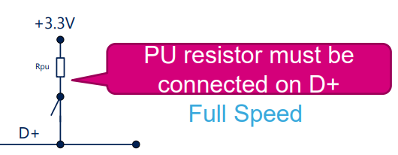
PULL DOWN RESISTOR: resistor attached to the Ground which forces the state LOW
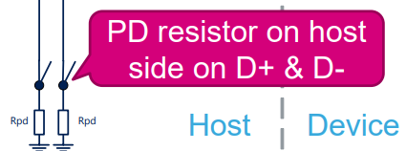
SE0 : D+ D- LOW SE1 : D+ D- HIGH
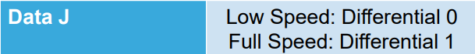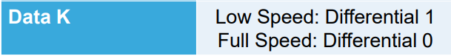
EXAMPLE : Consider a USB device transmitting the binary sequence "1010". The device will alternate between the J-state and K-state as follows:
- '1': J-State - D+ is high, D- is low (Full-Speed USB)
- '0': K-State - D+ is low, D- is high (Full-Speed USB)
- '1': J-State - D+ is high, D- is low (Full-Speed USB)
- '0': K-State - D+ is low, D- is high (Full-Speed USB)
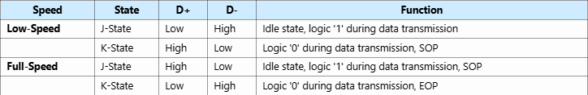
CONNECTION
LOW SPEED detection and IDLE state(J-state)(DIFF1)
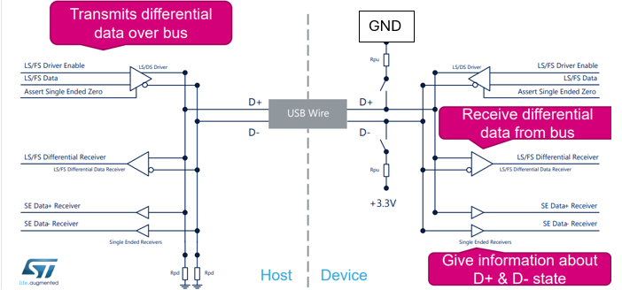
K-state(DIFF0) :
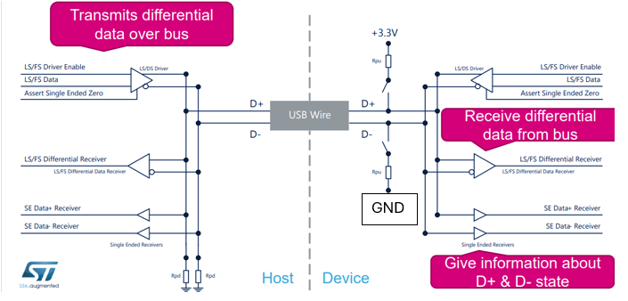

FULL SPEED detection and IDLE state(J-state)(DIFF1)

K-state(DIFF0) :

GND

Internal DMA
This DMA (Direct Memory Access) controller allows peripherals to directly access memory without involving the CPU, which can significantly improve performance and reduce CPU load.
- DMA Controller: The DMA controller in STM32 microcontrollers manages data transfers between memory and peripherals or between different memory locations. It operates independently of the CPU, allowing for efficient data movement.
- Channels and Streams: The DMA controller has multiple channels or streams, each of which can be configured to handle a specific data transfer task. Each channel can be associated with a specific peripheral.
- Configuration: To use DMA, you need to configure the DMA controller, including:
  - The source and destination addresses.
  - The data direction (memory-to-peripheral, peripheral-to-memory, or memory-to-memory).
  - The data size (byte, half-word, or word).
  - The number of data items to transfer.
  - The peripheral and memory increment modes.
Scatter-Gather?
Scatter-gather allows a DMA controller to transfer data between multiple source and destination addresses in a single DMA transaction. Instead of transferring a large block of contiguous data, scatter-gather enables the transfer of smaller, non-contiguous blocks of data, which can be scattered throughout memory or gathered into a single buffer.
How Scatter-Gather Works
- Descriptor Lists: Scatter-gather DMA uses descriptor lists (or tables) that contain information about each segment of data to be transferred. Each descriptor typically includes:
  - The source address.
  - The destination address.
  - The size of the data segment.
  - Control information (e.g., transfer direction, interrupt settings).
- Chaining Descriptors: Descriptors are chained together, allowing the DMA controller to process them sequentially. Once the DMA controller completes a transfer described by one descriptor, it automatically moves to the next descriptor in the chain.
- Automatic Handling: The DMA controller handles the entire scatter-gather operation automatically, without CPU intervention between individual transfers. This reduces CPU overhead and improves efficiency.
Scatter-Gather in STM32 DMA
In STM32 microcontrollers, the DMA controller can be configured to support scatter-gather operations, although the specific implementation details and capabilities may vary depending on the STM32 series and model.
Here’s how scatter-gather works with internal DMA in STM32:
- DMA Streams/Channels: Each DMA stream or channel can be configured to handle scatter-gather operations. Descriptors for scatter-gather transfers are set up in memory.
- Linked List Mode: Some STM32 models support a linked list mode (LLM) for DMA, where a chain of descriptors is used to describe the scatter-gather operation.
- Peripheral Support: Scatter-gather can be used with various peripherals, including USB, UART, SPI, and others. For example, in USB transfers, scatter-gather can be used to handle multiple USB packets that are scattered in memory.

DEVICE MODE HARDWARE DESIGN
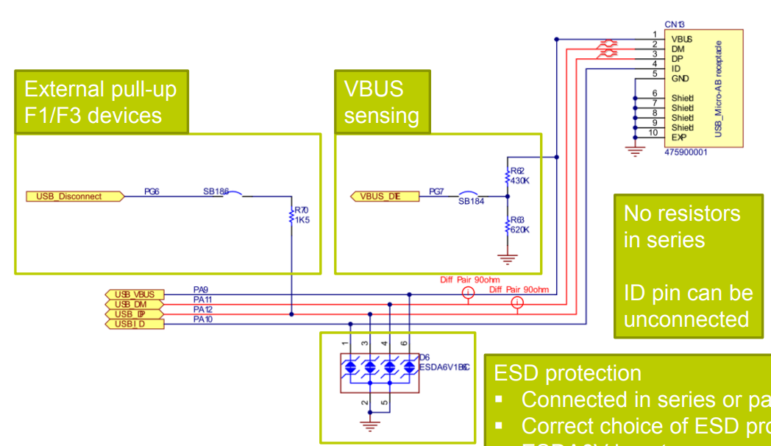
The hardware design is composed of
- VBUS sensing detects the presence of USB power to determine if a USB cable is connected, enabling proper USB enumeration and power management
- ESD protection safeguards the USB circuitry from electrostatic discharge events using devices like TVS diodes, preventing damage during connection or disconnection of cables. Both ensure reliable and robust USB operation.

HOST MODE HARDWARE DESIGN
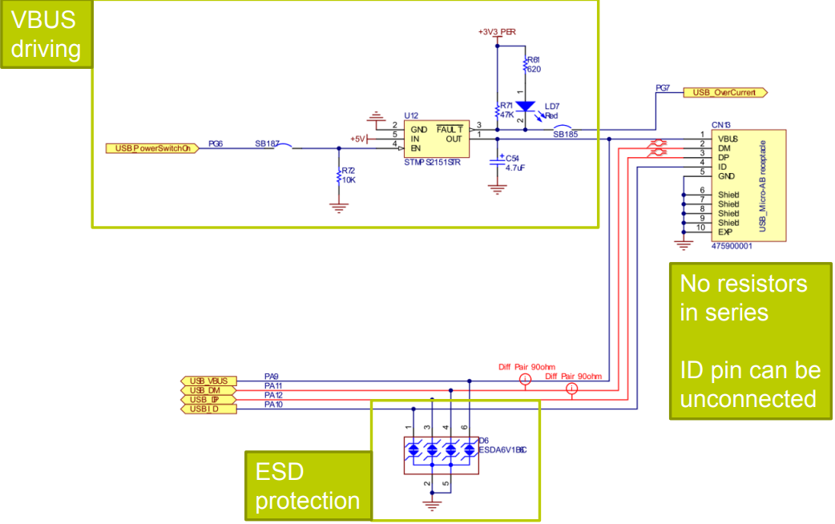
VBUS sensing and driving in host mode involves detecting and supplying USB power to connected devices, enabling proper USB enumeration and power management.
- ESD protection safeguards the USB circuitry from electrostatic discharge events using devices like TVS diodes, preventing damage during connection or disconnection of cables. Both ensure reliable and robust USB operation
ESD TYPES :
USBLC6-2 for DEVICE/HOST only (no ID pin)
For self powered application or OTG (ID usage) USBLC6-4SC6 is recommended
ECMF02-4CMX8 recommended for HS (ESD+EMI) , USBLC6-2SC6 can be also used, but additional EMI common mode filter need to be added

